LOST CAT

My name is Felix
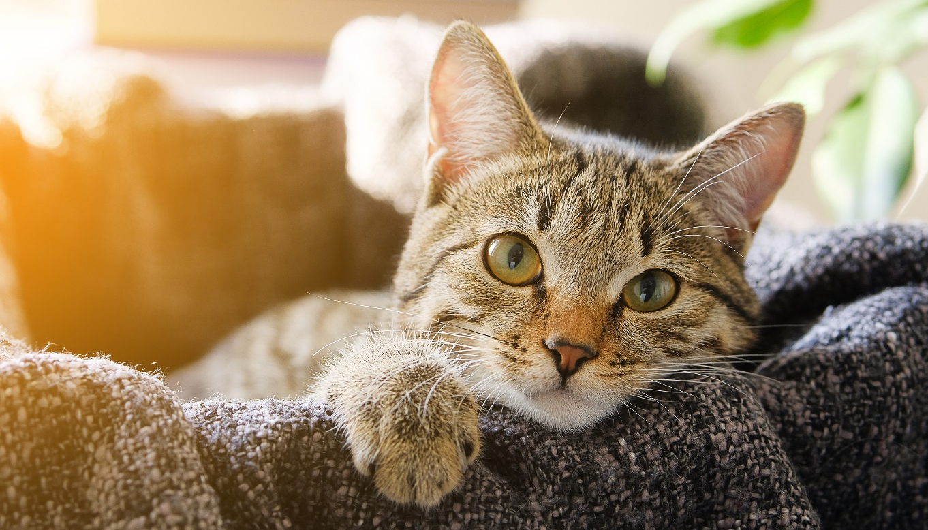
 | Felix was last seen on Barrack Street, Barrack Heights on Tuesday 14 April, heading north. | Breed |  | Domestic Short Hair
 |  | Age |  |  | 4yrs
 |  | Colour | Grey & White
 |  | Temperament |  |  |  | Friendly
 |  | Gender |  |  |  | Male

If you see him, please call Sandy on 0404 040 040.
Felix is missed dearly by his family.
FELIX IS MISSING  0404 040 040 | FELIX IS MISSING  0404 040 040 | FELIX IS MISSING  0404 040 040 | FELIX IS MISSING  0404 040 040 | FELIX IS MISSING  0404 040 040 | FELIX IS MISSING  0404 040 040 | FELIX IS MISSING  0404 040 040 | FELIX IS MISSING  0404 040 040 | FELIX IS MISSING  0404 040 040 | FELIX IS MISSING  0404 040 040

